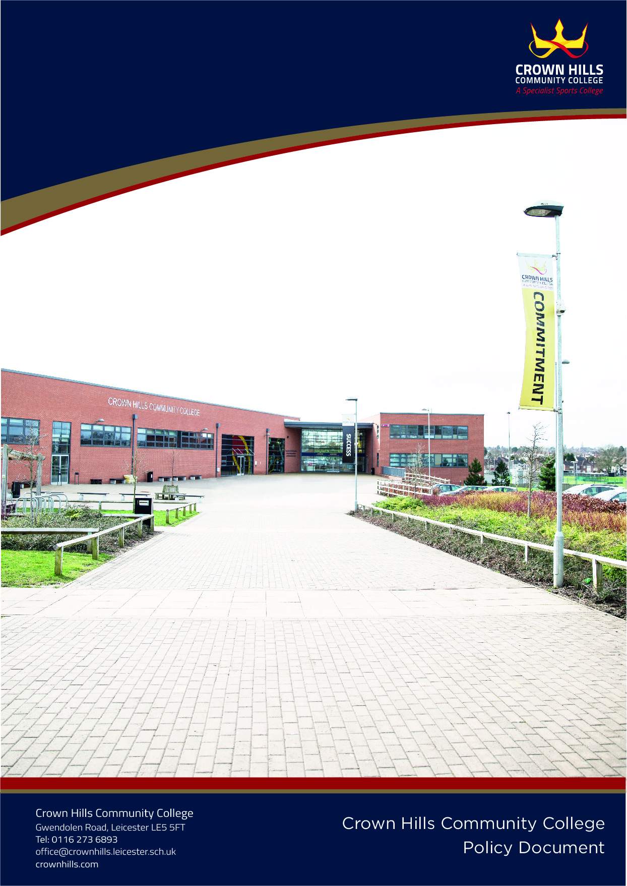
Charging and Remissions Policy
Policy Date: | Feb 2022 | Version:
Next Review: | Feb 2024 | Principal; Mr. Farhan Adam | Signature | Date
Ratified by Governing Body:
 |  | SLT Link: JFO | Date Reviewed: Feb 2023

Introduction

The Education Act 1996 (Sections 449-462) sets out the law on charging for school activities. It states that schools have a duty to provide parents with information regarding the charges that can and cannot be made for the services and activities provided by the School.

Crown Hills believes that a full and varied education should be available to all students. The college recognises that for many families, well organised activities are welcomed as they offer the opportunity for students to participate in activities that would otherwise be unavailable or would be too costly to provide outside of the college setting.

Aim

The aim of this policy is to set out what charges will be levied for activities, the circumstances under which voluntary contributions will be requested from parents and what support is available to parents on low incomes and /or in receipt of benefits.

Responsibilities

The Governing Body of the college are responsible for determining the content of this policy and the Principal is responsible for ensuring that it is implemented.

Prohibition of Charges

Under the current legislation, Crown Hills cannot charge for the following:

• education provided during school hours including the supply of any materials, books, instruments or other equipment

• education provided outside school hours (including trips), if it is part of the National Curriculum, or part of a syllabus for a prescribed public examination that the pupil is being prepared for at the college, or part of religious education;

- tuition for students learning to play musical instruments if the tuition is required as part of the National Curriculum, or part of a syllabus for a prescribed public examination that the pupil is being prepared for at the college, or part of religious education;

• entry for a prescribed public examination or examination re-sit, if the student has been prepared for it at the school; (all students will be given one opportunity to re-sit where the college deems it appropriate and SLT has given approval) .

• Supply teachers to cover for those teachers who are absent from college accompanying pupils on a residential trip;

• transporting registered students to or from the school premises, where:

- there is a statutory obligation to provide transport;
- the Governing Body/LA has arranged for a student to be educated;
- transport enables a student to meet an examination requirement when the student has been prepared for that examination at the school;

• transport provided in connection with an educational trip.

Publication of Information

A summary of this policy will be included in the School Prospectus and will specify what charges are/are not to be made and for which activities voluntary contributions will be invited from parents.

Charges

The school can charge for the following:
- any materials, books, instruments or equipment, that the student’s parent wishes them to own
- music and vocal tuition, if this is not part of the National Curriculum or a public examination syllabus
- Optional Extras. Charges may be made for :
- travel
- materials and equipment
- Non-teaching staff costs
- teaching staff purely employed for this purpose
- entrance fees
- insurance costs
- board and lodging on residential visits activities

If the activity is wholly or mainly outside school hours and is not part of the National Curriculum, part of a public examination or part of religious education

- examination entry fees where the student has not been prepared by the school
- breakages and replacements as a result of damages caused willfully or negligently by pupils
- extra-curricular activities and school clubs.
- If a student fails, without good reason, to meet any examination requirement for a syllabus, the fee can be recovered from the student’s parents.

Support to Families on Low Incomes

The School holds a limited amount of discretionary funds, which may be used at the request of an activity organiser, in consultation with the Educational Visits Co-ordinator and the appropriate Head of Faculty to offer top-up funding for individual students in cases of proven hardship.

Leaders of educational trips whose cost exceeds £250 per student, are required to ensure that adequate time is allowed (6-10 months) for parents to raise the funds.

Voluntary Contributions

Parents will be invited to make voluntary contributions for the benefit of the school for the following activities:

a) Food and Design Technology, where the finished product is to be taken home.

b) Trips - if an activity cannot be funded without these contributions, this will be made clear at the outset. If insufficient voluntary contributions are raised to fund an activity, then it will be cancelled.

Any request made to parents will specify:
- That the contribution is genuinely voluntary and that they are under no obligation to pay; and

- That registered students at the school will not be treated differently according to whether or not
their parents have made any contribution in response to the request.

The responsibility for determining the level of the voluntary contribution is delegated to the
Principal and is dependent upon the activity.

Voluntary contributions will be used solely to support the cost of the activity or to maintain the level of departmental resources.

Facilities Hire

The School is able to levy a charge for the hire of internal and external facilities at Crown Hills for community and commercial activities.

Facility Charges 2022/23

All bookings from 1 April 2023 will be charged the appropriate rate set out below

Bookings of 10 sessions or more (before VAT)

Per 55 minutes | 2022/23  £
Classroom | 12.00
Assembly hall (Space only) | 30.00
Assembly Hall (Seating, lights etc) | 40.00
Auditorium | 30.00
Food Hall | 30.00
Sports hall – half hall | 50.00
Netball Court | 20.00
Cricket net | 20.00
Badminton Court | 15.00
Tennis Court | 35.00
Basketball Court | 40.00
Indoor Football Court | 40.00
Football Pitch (external) | 25.00
Activity Studio | 20.00
Plaza | 30.00
Sports Field | POR

The following information from the groups will also need to be provided before any usage:

An enhanced DBS of all personnel working with young people.
A letter from the NGB / Organisation stating they have carried out the DBS checks.
A list of first aiders.
A lettings agreement - signed.
A brief overview of all activities delivered.
A license to perform (Dance Schools).

The school has the discretion to apply discounts for community-based groups that have a significant positive impact on the school. Before this discount is applied, the governing body will be advised and given the opportunity to make appropriate comments.

Any person/group running an activity/class on a profit making basis as an on-going business will be charged a higher specially negotiated rate.

A review of all the above arrangements will take place annually.

This policy has been written in conjunction with the college’s Equality and Diversity policy (Equality Act 2010)

